Mckenna Bird
INTS 4990
Professor Martin Widzer
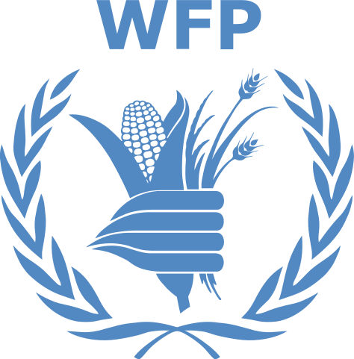
WORLD FOOD PROGRAM (WFP)
“Assisting 86.7 million people in around 83 countries each year, the World Food Programme (WFP) is the leading humanitarian organization saving lives and changing lives, delivering food assistance in emergencies and working with communities to improve nutrition and build resilience.”

As the Director of the World Food Program, our mission is to end hunger by 2030 through resilience building, emergency relief, humanitarian support and services, food assistance, and cooperation with developing nations.
- Resilience Building:
In an effort to continue improving food security and nutrition, we assist the most vulnerable people in strengthening their capacities to absorb, adapt, and transform in the face of shocks and long-term stressors.
- Emergency Relief:
The World Food Program responds to emergencies to help with direct assistance where it is most needed. Our global networks have developed quality emergency programs that help us plan ahead, pre-position supplies, and minimize the time needed to deliver life-saving food assistance.
- Humanitarian Support and Services:
We lead humanitarian response organizations during emergencies that aid in logistics, emergency telecommunications, and food security in times of need.
- Food Assistance:
Where food is scarce, the World Food Program distributes food or offers vulnerable people cash and vouchers to buy nutritious ingredients. This system allows people choice and protects them from financial exploitation while supporting the local economy.
- Cooperation with Developing Nations:
In an effort to end hunger, the World Food Program supports governments of developing nations in the transfer of knowledge, skills, resources, as well as through policy, advocacy and regional collective action in order to strengthen the national capacities and develop sustainable solutions.

https://www.wfp.org/

