DATE: April 27, 2020 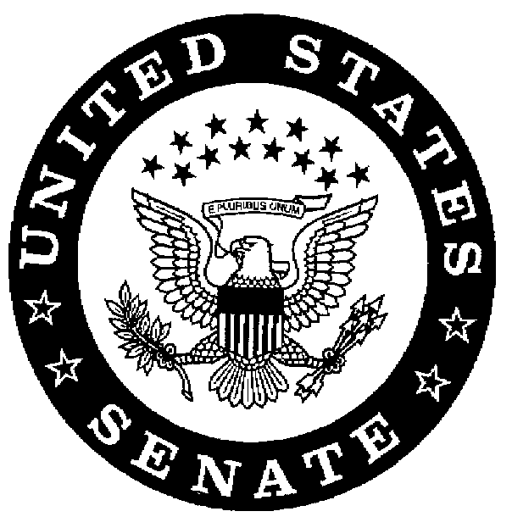
MEMORANDUM FOR: Chief of Staff Melissa Randall
FROM: Jesse Nickerson – Congressional Liaison
SUBJECT: Recommendation for Distinguished Intelligence Cross to Intel Officer Hood
STATUS: URGENT
Dear Chief of Staff Randall,
It is with great honor that the national security council recommend that, along with the efforts from Chief of Staff, Director of National Intelligence, the National Security Advisor, and the Secretary of Defense, Intel Officer Adrian Hood receive the Distinguished Intelligence Cross for his efforts during President Widzer’s abduction. His intelligence memos, sent with great urgency and swiftness during this national peril, were instrumental in helping the United States rescue our President.
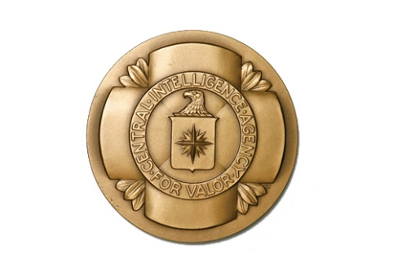 Respectfully,
Jesse Nickerson
Congressional Liaison
Advisor to Chief of Staff

