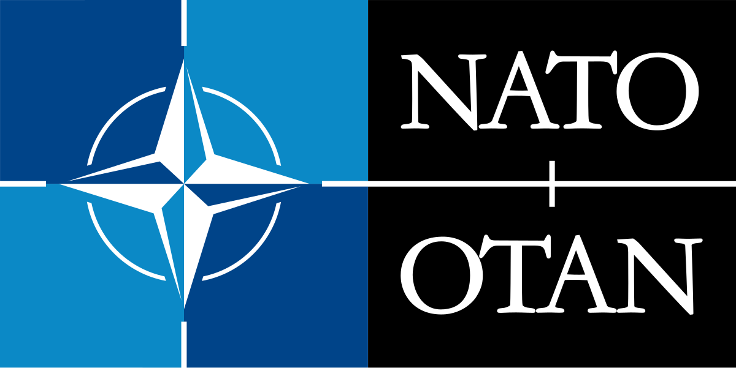
NATO Secretary General -Laura Herrera
Classified Distribution:
Chief of Staff Secretary of Defense
DNI National Security Advisor
WHO Member States

Region-Wide Bulletin
17 April 2020 16:12 EEST
Subject: Reports from intelligence officers state that there is need for supplies and aid to multiple regions in response to the COVID- 19 outbreak.
In addition, some Eastern European countries such as Serbia and Hungary have felt that they are not receiving the aid they need from the EU to fight COVID-19. Therefore, they have tightened bonds with Russia and China. Serbian president Aleksandar Vucic reportedly said, “Only China can help us.”.
Action: It is recommended that the United States as well as the member states of NATO provide at least 1.8% of their overall GDP to NATO so that the organization can provide sufficient support to its members and elsewhere needed.

Est Cost: $2,500,000,000 billion

