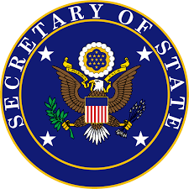
From the Desk of the Honorable Sakthi Asokan
Secretary of State

The President of the United States appoints his Secretary of State, who needs to be approved by the Senate. They are the President's principal advisor on US foreign policy, providing information to the US government and the US people about the political, economic, and social aspects of foreign states. They are also the Chief Diplomat, so they lead any negotiations. If any international treaties or agreements exist or are created, the Secretary of State also interprets them and can terminate them. They are the middleman in a any communications regarding extraditing a fugitive to or from foreign states. The Secretary of State also advises the President on appointing any diplomatic representatives such as US ambassadors, ministers, consuls, and foreign service officers. They also supervise the Foreign Service. Similarly, they advise the President on accepting or dismissing any representatives from foreign government. They supervise US immigration laws abroad and protect US citizen rights, properties, and interests in foreign states.
While being largely involved in US foreign affairs, the Secretary of State maintains some domestic duties under the State Department. They are responsible for the custody of the Great Seal, which is the main US national symbol for sovereignty. They prepare some presidential proclamations on foreign policy matters. They also keep official US record of treaties (both those in and out of US custody), international acts, and US foreign relations.

Summary of Main Roles:
- Chief Diplomat
- Advisor on US foreign policy and foreign representative appointments
- Supervise immigration law and protect US citizens when they are abroad

