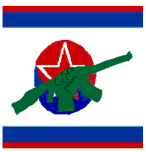
Foolish American Swine.
Popular Front for the
Unification of Korea
الجبهة الشعبية لتوحيد كوريا

통일 전선

Do you honestly believe we are ruled by the illegitimate dictator
of the North?

Do you honestly believe we are directed by the chaotic kleptocracy
of the South?

WE WILL UNITE KOREA BY ALL MEANS NECSSARY

For once your silly old Dotard is correct in recognizing that your Puppet of State is “wasting his time trying to negotiate.” We will never succumb to the whims of crazy ‘twitter’ man.

A United Korea is non-negotiable and President Widzer will know our wrath should he attempt to stand in our way!
أيها الإخوة الكرام، التعزيزات في الطريق. كونوا على العهد.
الله معكم.
10.491751327700491, -67.9474537118719:YYP2916:D113025:T2301

